

NATIONAL INSTITUTE OF
CARDIAVASCULAR DISEASES
Theories of Nursing Practice and management…



No 2

Apply knowledge of relevant theories and skills
in specified area of nursing practice

What is theory?
- Theories as a set of interrelation concepts that gives systemic view of phenomena that is explanatory & predictive in nature…
- Concepts are basically vehicles of thought that involve images, concepts are two words that describe the objects, properties and events that are basically component of theory….
Types of nursing theories:
Grand nursing theories
Grand nursing theories have the broadest scope and present general concepts and propositions. Theories at this level may both reflect and provide insights useful for practice but are not designed for empirical testing. This limits the use of grand nursing theories for directing, explaining, and predicting nursing in particular situations. Theories at this level are intended to be pertinent to all instances of nursing.
Mid-range nursing theories
Middle-range nursing theories are narrower in scope than grand nursing theories and offer an effective bridge between grand nursing theories and nursing practice. They present concepts and propositions at a lower level of abstraction and hold great promise for increasing theory-based research and nursing practice strategies.
Nursing practice theories
Nursing practice theories have the most limited scope and level of abstraction and are developed for use within a specific range of nursing situations. Nursing practice theories provide frameworks for nursing interventions, and predict outcomes and the impact of nursing practice.
The Role of Theory in Clinical Nursing Practice
A General Un‐specified role:
- – To shape & undergird how nursing is to be practiced in general regardless of clinical situation
- – As the base level for a foundation‐building
- – Providing the basic orientations, attitudes, and commitments regarding one’s practice.
A particularistic, situation‐ specific role:
- – To respond to requirements of specific clinical situations for nursing practice
- – As the second level for action‐formulation
- – Providing specific ways of nursing practice to fit to unique
- --Requirements of specific clinical situations
The role of theory in line with the development of nursing theories
- – Grand theory development from the 1960sto 1980s
- --Institutionalization of grand theories into the system of nursing process
- – Middle‐range theory develop men since the middle of 1980s
- --Situation‐specific applications
- – Development of intervention theories in the 1990sto the present
- --Problem‐specific applications
The role of theory in relation to the scientification of nursing practice
- – Movement away from medicine –Nursing as a scientific discipline
- – Movement in practice guidelines and evidence‐based practiced he Role of Theory in relation to the Model.

The Role of Theory in relation to the Model of Nursing Practice:
The Base Level:  The General, Un‐  specified  Role | Role for establishing  orientations,  attitudes, and  commitments for  general nursing  practice | Theories for the structure of frame  (Establishing nursing perspectives regarding  humans & practice) Theories for the structure of philosophy  (Establishing specific features of the  philosophies of care, therapy, & professional  work)
The Second Level:  The Particularistic,  Situation‐specific  Role | Role for providing  theoretical rationale  for specific nursing  actions | Theories for the Structure of Dimensions  (Providing the theoretical rationale for the  characteristics in scientific, technical,  ethical, aesthetic, & existential dimensions  of practice)

The importance of nursing theory
Theory is important because it helps us to decide what we know and what we need to know (Parsons1949). It helps to distinguish what should form the basis of practice by explicitly describing nursing. The benefits of having a defined body of theory in nursing include better patient care, enhanced professional status for nurses, improved communication between nurses, and guidance for research and education (Nolan 1996). In addition, because the main exponent of nursing – caring – cannot be measured, it is vital to have the theory to analyze and explain what nurses do Nolan et al (1998) note the disparity between current trends in the healthcare service. As medicine tries to make a move towards adopting a more multidisciplinary approach to health care, nursing continues to strive to establish a unique body of knowledge. This can be seen as an attempt by the nursing profession to maintain its professional boundaries. The issue is blurred further because the boundaries between nursing and medicine are never static. For example, as nurses increasingly extend their scope of practice by performing tasks previously carried out by doctors, many of their own traditional roles are being passed on to healthcare assistants However, because these boundaries are constantly changing, perhaps it is more important than ever that nurses are able to define their position and their role. By providing nurses with a sense of identity, nursing theory can help patients, managers and other healthcare professionals to recognize the unique contribution nurses make to the healthcare service (Draper 1990). A formal definition of nursing theory also provides nurses with an understanding of their purpose and role in health care.
Practice of Nursing Theories
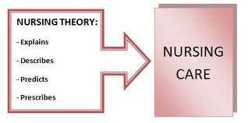

Practice of nursing theories cont.
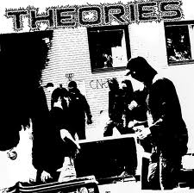



Nursing management theories and educational theories.
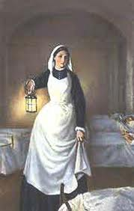
- Florence Nightingale- Environmental Theory
- Based on psychodynamic nursing
- USING an understanding of one’s own behavior to help
others identify their difficulties.
- Applies principles of human relations
- Patient has a felt need

1 Person
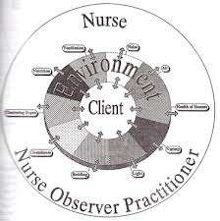
Patient who is acted on by nurse affected by environment
has reparative powers
2. Environment
Foundation of theory. Included everything, physical,
psychological, and social
3. Health
Maintaining well-being by using a person’s powers maintained by control of environment.
4. Nursing
Provided fresh air, warmth, cleanliness, and good diet, quiet to facilitate person’s reparative process.

- Hildegard Peplau -Interpersonal Relations Model
- Based on psychodynamic nursing
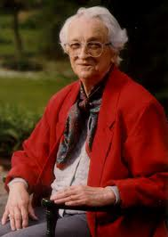
- using an understanding of one’s own behavior to help others identify their difficulties
- Applies principles of human relations
- Patient has a felt need
Peplau’s Concepts
1. Person
- An individual; a developing organism who tries to reduce
anxiety caused by needs
- Lives in instable equilibrium
2. Environment
- Not defined
3. Health
- Implies forward movement of the personality and human processes toward creative, constructive, productive, personal, and community living
4. Nursing
- A significant, therapeutic, interpersonal process that functions cooperatively with others to make health possible
- Involves problem-solving.

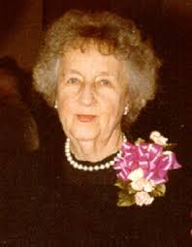
- Virginia Henderson -The Nature of Nursing
"The unique function of the nurse is to assist the individual,
sick or well, in the performance of those activities contributing to
health or its recovery (or to peaceful death) that he would perform
unaided if he had the necessary strength, will, or knowledge.
And to do this in such a way as help him gain independence as
rapidly as possible. She must in a sense, get inside the skin of
each of her patients in order to know what he needs".

- Fay Abdella- Topology of 21 Nursing Problems
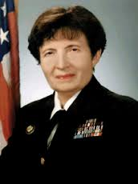
- A list of 21 nursing problems
- Condition presented or faced by the patient or family.
- Problems are in 3 categories
  - physical, social and emotional
- The nurse must be a good problem solver
Abdella’s Concepts
1. Nursing
- A helping profession
- A comprehensive service to meet patient’s needs
- Increases or restores self-help ability
- Uses 21 problems to guide nursing care
2. Health
- Excludes illness
- No unmet needs and no actual or anticipated impairments
3. Person
- One who has physical, emotional, or social needs
- The recipient of nursing care.
4. Environment
- Did not discuss much
- Includes room, home, and community.

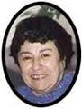
- Ida Jean Orlando- Deliberative Nursing Process
The deliberative nursing process is set in motion by the patient’s
behavior. All behavior may represent a cry for help. Patient’s behavior
can be verbal or non-verbal. The nurse reacts to patient’s
behavior and forms basis for determining nurse’s acts.
Perception, thought, feeling Nurses’ actions should be deliberative,
rather than automatic Deliberative actions explore the meaning and
relevance of an action.
- Dorothy Johnson-Behavioral Systems Model
The person is a behavioral system comprised of a set of organized, interactive, interdependent, and integrated subsystems constancy is maintained through biological,
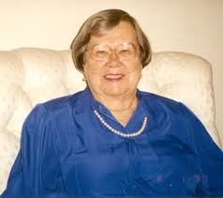
psychological, and sociological factors. A steady state is maintained through adjusting and adapting to internal and external forces.
- Affinitive subsystem - social bonds
- Dependency - helping or nurturing
- Ingestive - food intake
- Eliminative - excretion
- Sexual - procreation and gratification
- Aggressive - self-protection and preservation
- Achievement - efforts to gain mastery and control
Johnson’s Concepts
1. Person
- A behavioral system comprised of subsystems constantly trying to maintain a steady state
2. Environment
- Not specifically defined but does say there is an internal and external environment
3. Health
- Balance and stability.
4. Nursing
- External regulatory force that is indicated only when there is instability.

- Martha Rogers -Unitary Human Beings
Energy fields
- Fundamental unity of things that are unique, dynamic, open, and infinite
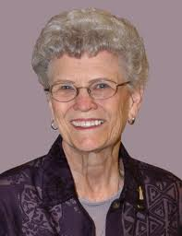
- Unitary man and environmental field
Universe of open systems
- Energy fields are open, infinite, and interactive
Pattern
- Characteristic of energy field
- A wave that changes, becomes complex and diverse
Pan dimensionality
- A nonlinear domain without time or space

- Roger’s Definitions
Integrality
- Continuous and mutual interaction between man and environment
Resonance
- Continuous change longer to shorter wave patterns in human and environmental fields
Helicy
- Continuous, probabilistic, increasing diversity of the human and environmental fields.
- Characterized by no repeating rhymicities
- Change.

- Dorothea Orem- Self-Care Model
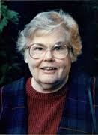
Self-care comprises those activities performed independently by an individual to promote and maintain person well-being Self care agency is the individual’s
ability to perform self care activities Self- care deficit occurs
when the person cannot carry out self-care.
The nurse then meets the self-care needs by acting or doing for;
guiding, teaching, supporting or providing the environment to
promote patient’s ability wholly compensatory nursing system.
Patient dependent partially compensatory. Patient can meet
some needs but needs nursing assistance supportive educative-
patient can meet self care requisites, but needs assistance with decision making or knowledge.
- Imogene King-Goal Attainment Theory
- Open systems framework
- Human beings are open systems in constant interaction with the environment
- Personal System
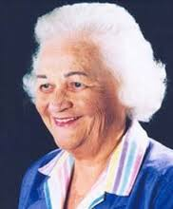
  - individual; perception, self, growth, development, time space, body image
  - Interpersonal
  - Society
- Personal System
  - Individual; perception, self, growth, development,
time space, body image
- Interpersonal
  - Socialization; interaction, communication and transaction
- Society
  - Family, religious groups, schools, work, peers
- The nurse and patient mutually communicate, establish goals and take action to attain goals
- Each individual brings a different set of values, ideas, attitudes, perceptions to exchange.

- Betty Neuman - Health Care Systems Model
- The person is a complete system, with interrelated parts
- maintains balance and harmony between internal and external environment by adjusting to
stress and defending against tension-producing stimuli
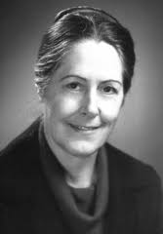
- Focuses on stress and stress reduction
- Primarily concerned with effects of stress on health
- Stressors are any forces that alter the system’s stability
- Flexible lines of resistance - Surround basic core
- Internal factors that help defend against stressors
- Normal line of resistance - Normal adaptation state
- Flexible line of defense - Protective barrier, changing,
affected by variables and Wellness is equilibrium
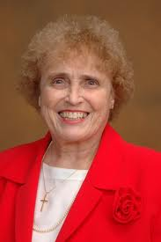
- Calista Roy Sister - AdaptationModel
Five Interrelated Essential Elements
- Patiency- The person receiving care
- Goal of nursing- Adapting to change
- Health-Being and becoming a whole person
- Environment
- Direction of nursing activities- Facilitating adaptation
- The person is an open adaptive system with input
(stimuli), who adapts by processes or control mechanisms (throughput)
- The output can be either adaptive responses or ineffective responses

- Jean Watson - Philosophy and Science of Caring

- Caring can be demonstrated and practiced
- Caring consists of creative factors
- Caring promotes growth
- A caring environment accepts a person as he is and looks to what
the person may become
- A caring environment offers development of potential
- Caring promotes health better than curing
- Caring is central to nursing
- Watson’s Concepts
- Person
- Human being to be valued, cared for, respected, nurtured, understood and assisted
- Environment
- Society
- Health
- Complete physical, mental and social well-being and functioning
- Nursing
- Concerned with promoting and restoring health, preventing illness.

Watson’s 10 Carative Factors
- Forming humanistic-altruistic value system
- Instilling faith-hope
- Cultivating sensitivity to self and others
- Developing helping-trust relationship
- Promoting expression of feelings
- Using problem-solving for decision making
- Promoting teaching-learning
- Promoting supportive environment
- Assisting with gratification of human needs
- Allowing for existential-phenomenological forces

Rosemary Parse - Human Becoming Theory
- Human Becoming Theory includes Totality Paradigm
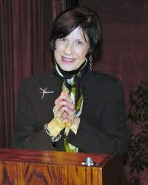
- Man is a combination of biological, psychological, sociological and spiritual factors
- Simultaneity Paradigm
- Man is a unitary being in continuous, mutual interaction
with environment
- Originally Man-Living-Health Theory
- Parse’s Three Principles
- Meaning
- Man’s reality is given meaning through lived experiences
- Man and environment cocreate
- Rhythmicity
- Man and environment cocreate (imaging, valuing, and language) in rhythmical patterns.
Parse’s Three Principles:
- Co transcendence
  - Refers to reaching out and beyond the limits that a person sets
  - One constantly transforms
- Person
  - Open being who is more than and different from the sum of the parts
- Environment
  - Everything in the person and his experiences
  - Inseparable, complimentary to and evolving with

- Health
  - Open process of being and becoming. Involves synthesis of values
- Nursing
  - A human science and art that uses an abstract body of knowledge to serve people

- Madeleine Leininger - Culture Care Diversity and Universality
- According to transcultural nursing, the goal of nursing care is to provide care congruent with cultural values, beliefs, and practices
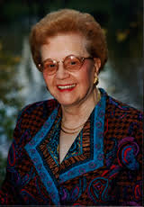
- Sunrise model consists of 4 levels that provide a base of knowledge
for delivering cultural congruent care.
- Cultural care preservation
  - help maintain or preserve health, recover from illness, or face death
- Cultural care accommodation
  - help adapt to or negotiate for a beneficial health status, or face death
- Cultural care re-patterning
  - Help restructure or change lifestyles that are culturally meaningful.

Patricia Benner - From Novice to Expert
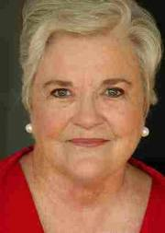
- Described 5 levels of nursing experience and developed exemplars and paradigm cases to illustrate each level
- Novice
- Advanced beginner
- Competent
- Proficient
- Expert
- Levels reflect:
  - movement from reliance on past abstract principles to the use of past concrete experience as paradigms change in perception of situation as a complete whole in which certain parts are relevant.

Lydia E. Hall - The Core, Care and Cure
- The theory contains of three independent but interconnected circles:
  - the core,
  - the care and
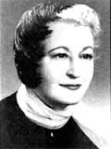
  - the cure
- The core is the person or patient to whom nursing care is
directed and needed. The core has goals set by himself and
not by any other person. The core behaved according to his feelings, and value system.
- The care circle explains the role of nurse
- The cure is the attention given to patients by the medical professionals.
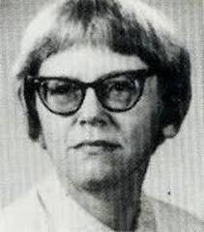
Joyce Travelbee Human-To-Human Relationship Model …
- Joyce Travel bee (1926-1973) developed the
- Human-to-Human
Relationship Model presented in her
Book Interpersonal Aspects of Nursing (1966, 1971).
- She dealt with the interpersonal aspects of nursing.
- She explains “human-to-human relationship is the means through which the purpose of nursing if fulfilled”
Description of the theory :
- Travel bee believed nursing is accomplished through human-to-human relationships that begin with the original encounter and then progress through stages of emerging identities, developing feelings of empathy, and later feelings of sympathy.
- The nurse and patient attain a rapport in the final stage. For meeting the goals of nursing it is a prerequisite to achieving genuine human-to-human relationships.
- This relationship can only be established by an interaction process.
- It has five phases.
  - The inaugural meeting or original encounter
  - Visibility of personal identities/ emerging identities.
  - Empathy
  - Sympathy
  - Establishing mutual understanding and contact/ rapport
- Travelbee's ideas have greatly influenced the hospice movement in the west.

Maslow's theory of motivation
- Maslow's hierarchy of needs is a theory in psychology proposed by Abraham Maslow in his 1943 paper "A Theory of Human Motivation". Maslow subsequently extended the idea to include his observations of humans' innate curiosity. His theories parallel many other theories of human developmental psychology, some of which focus on describing the stages of growth in humans. Maslow used the terms Physiological, Safety, Belongingness and Love, Esteem, Self-Actualization and Self-Transcendence needs to describe the pattern that human motivations generally move through.
- Maslow studied what he called exemplary people such as Albert Einstein, Jane Addams, Eleanor Roosevelt, and Frederick Douglass rather than mentally ill or neurotic people, writing that "the study of crippled, stunted, immature, and unhealthy specimens can yield only a cripple psychology and a cripple philosophy." Maslow studied the healthiest 1% of the college student population.
- Maslow's theory was fully expressed in his 1954 book Motivation and Personality. While the hierarchy remains a very popular framework in sociology research and secondary and higher psychology instruction, it has largely been supplanted by attachment theory in graduate and clinical psychology and psychiatry.
